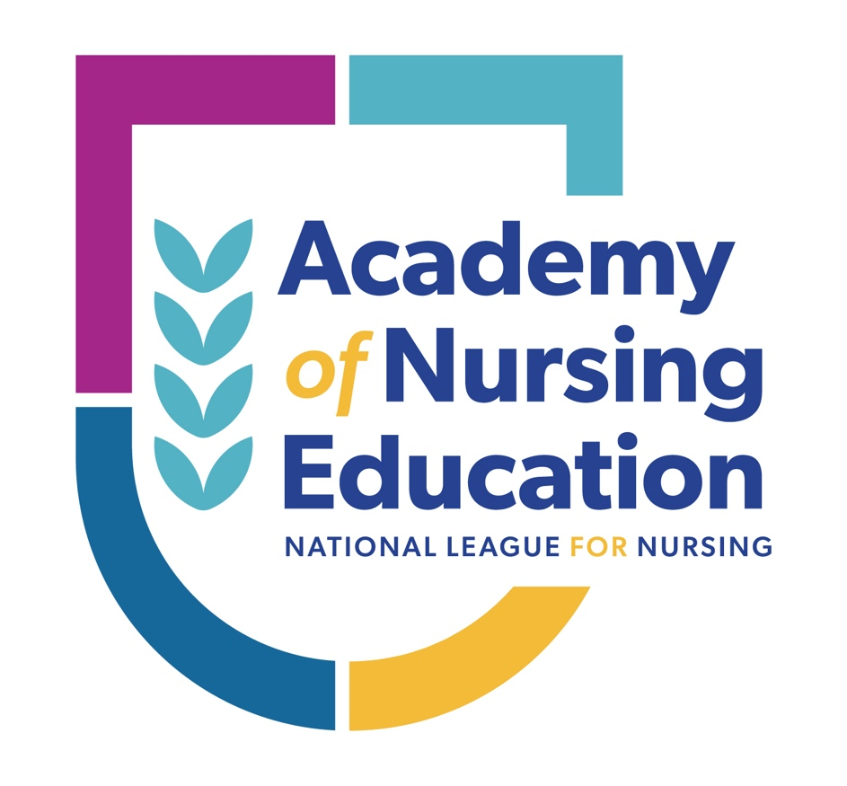

Academy of Nursing Education Handbook
Regular Application

(Last updated: August 16, 2024)

Table of Contents

About the Academy of Nursing Education | 3
Comparison of Application Types | 4
Eligibility Criteria | 5
Application Details | 6-8
Application Timeline and Fees | 9
Frequently Asked Questions | 10-12
Self-Assessment | 13
About the Academy

The Academy of Nursing Education is an innovative program created to call attention to the exceptional work of those who are transforming nursing education.

History:
The NLN Academy of Nursing Education was created in 2007 to recognize and capitalize on the wisdom of outstanding individuals who have made enduring and substantial contributions to nursing education. There are currently more than 300 fellows in the Academy of Nursing Education.

Purpose:
The NLN Academy of Nursing Education fosters excellence in nursing education by recognizing and capitalizing on the wisdom of outstanding individuals in and outside the profession who have contributed to nursing education in a way that is substantive, enduring, and impactful. Fellows are expected to provide visionary leadership in nursing education and in the Academy, and to support the vision of the National League for Nursing.

Transform Nursing Education
Individuals inducted as fellows form a distinguished national and international network of educators whose accomplishments beyond their employment expectations are:

- Acknowledged for innovative teaching and learning strategies, nursing education research, faculty development, academic leadership, promotion of public policy that advances nursing education and collaborative educational practice with community partners.

- Recognized for their expertise in nursing education and are invaluable assets to the nursing education community.

- Dedicated to transforming nursing and nursing education by influencing change, advancing excellence in nursing education, and empowering others to achieve success as nurse educators within and external to one’s work role and position.

Academy Review Panel

All Academy applications are thoroughly reviewed by a panel of peers appointed by the NLN Chair. A candidate for review must be selected by an affirmative vote of 51 percent of the review panel members present and voting. Following the Academy Review Panel meeting, the NLN Board of Governors reviews and votes on all recommendations before candidates are notified of the panel’s decision. All decisions made by the review panel and NLN Board of Governors are final.

Comparison of Academy Application Types

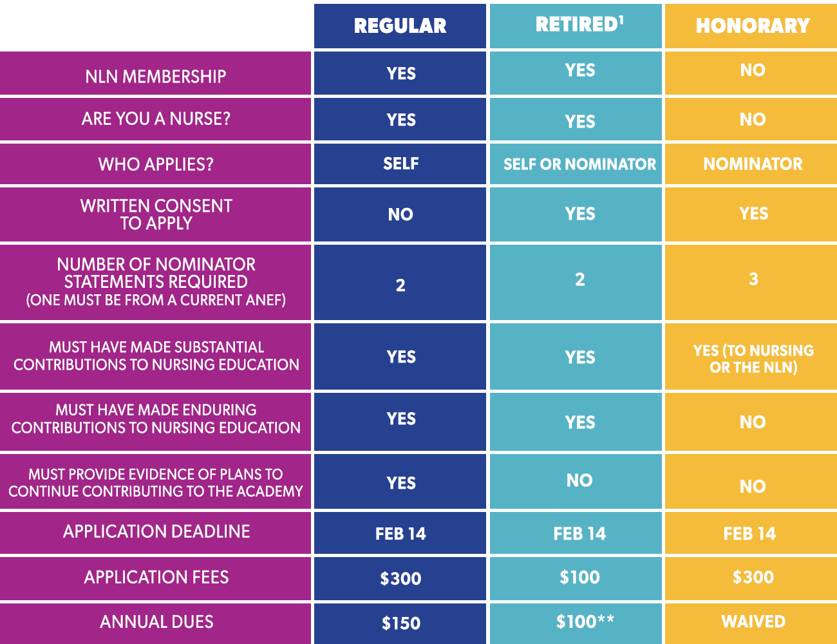

¹To be considered retired, the candidate must not have been employed in any capacity for at least three years. If the candidate has not been retired for three years, they must apply as a regular fellow.

* Current NLN Board of Governors, NLN Foundation Board of Trustees, CNEA Board of Commissioners, NLN Certification Board of Commissioners, Academy Review Panel members, and NLN staff may not be used as a nominator.

Regular Fellow Eligibility Criteria
A candidate for regular fellowship in the Academy of Nursing Education must:
- Be, or have been, a licensed nurse
- Provide evidence of substantial, enduring, and impactful contributions to nursing education in one of the following categories:
  - Teaching/Learning innovations
  - Faculty development
  - Research/scholarship in nursing education
  - Leadership in nursing education
  - Public policy related to nursing education
  - Collaborative partnerships (education/practice/community)

- Provide evidence of how they will continue to provide visionary leadership in nursing education and in the Academy.
- Provide evidence of how their contributions are congruent with the mission and goals of the NLN.
- Be a current member of the NLN (individually or through their school or agency).

NLN Mission Statement:
The National League for Nursing promotes excellence in nursing education to build a strong and diverse nursing workforce to advance the health of our nation and the global community.
Goal I | Leader in Nursing Education: Enhance the NLN's national and international impact as the recognized leader in nursing education.
Goal II | Commitment to Members: Lead a diverse, sustainable, member-focused organization that engages, empowers, and is responsive to nurse educators across the career continuum.
Goal III | Champion for Nurse Educators: Be the voice of nurse educators and champion their interests in political, academic, and professional arenas.
Goal IV | Advancement of the Science of Nursing Education: Promote research that generates evidence about nursing education and the scholarship of teaching.

Responsibilities of Fellows
All individuals accepted into fellowship in the Academy of Nursing Education are required to:
- Attend the Academy Induction Ceremony at the NLN Summit
- Maintain membership in the National League for Nursing
- Pay annual Academy membership dues
- Participate in the community of fellows as a means of transforming nursing education
- Mentor and support future fellows in their endeavor to join the Academy of Nursing Education
Regular Fellow Application Details
Individuals who meet eligibility criteria may apply for fellowship in the Academy by submitting a complete online application on, or before, February 14. Applicants should choose their area of contribution carefully. It should guide the entire application. Applications received after the deadline will not be considered. An application is considered to be complete only if all questions are answered within the word limit, nominator statements and CV meet the requirements below, and payment is submitted before the deadline. No applications will be accepted by mail or email. For your convenience, the essay questions required in the online application are included below.

Application Essay Questions:
You are strongly encouraged to use the answers from the self-assessment questions on page 13, in your essay questions below. The self-assessment was compiled to give candidates the best possible chance of being inducted into the Academy.

- Describe your primary area of contribution for which you are known in the nursing education community. (25 words maximum)
- Describe how you have made enduring and substantial contributions, beyond those required of your employment, that have had a significant impact on nursing education (state/regional/national and/or international) in your primary area of contribution. Provide specific examples. (600 words maximum)
- Describe how you have provided visionary leadership in nursing education. Refer to the FAQ section, “What is visionary leadership?” (200 words maximum)
- Describe how you will continue to provide visionary leadership in nursing education and in the Academy. (200 words maximum)
- Describe how your contributions are congruent with the mission and specific goals of the NLN. Provide specific examples. (100 words maximum).

Nominator Statements:
Please provide two (2) nominator statements that illustrate specific examples of your enduring and substantial work in the primary area of contribution and the work’s impact on nursing education (at state/regional/national and/or international level(s)). Nominator statement should expound on applicant’s accomplishments rather than solely repeating content from the applicant’s personal statement.
FAILURE TO FOLLOW THE REQUIREMENTS BELOW WILL RESULT IN A DISQUALIFIED APPLICATION.
Nominator statement requirements:
- At least one statement must come from an individual outside of your institution
- At least one statement must come from a current ANEF
- Formatting:
  - Addressed to “Academy of Nursing Education Review Panel Members”
  - 500-word limit
  - On formal letterhead
  - Signed by the writer
  - Submitted in PDF form
  - Include writer’s name, credentials, affiliation, and contact information
- NOTE: Current NLN Board of Governors, NLN Foundation Board of Trustees, CNEA Board of Commissioners, NLN Certification Board of Commissioners, Academy Review Panel members, and NLN staff may not be used as a nominator.
Recommendations for excellent nominator statements:
- Select nominators strategically. Consider individuals who can address your accomplishments and speak to the extent and significance of your contributions. Be sure each nominator addresses different strengths in their statement.
- Provide nominators with information bullets that specifically address your accomplishments relevant to your applicable area of contribution.
- Provide nominators with your curriculum vitae and essay question responses.
- Provide nominators with the NLN’s mission and goals.
- Provide nominators with this handbook to review thoroughly

For the nominator: Your comments should enhance the application without repeating examples and content already provided by the candidate. Please be specific about how the applicant has made substantial, enduring, and impactful contributions to nursing education (state/regional/national and/or international) in their primary area of contribution beyond their employment. It is recommended that you read the applicant’s curriculum vitae and essay question responses prior to writing the nominator statement. Questions about the specific nominator statement you are preparing should be directed to the candidate.

Curriculum Vitae:
Please provide a CV that enhances your overall application, substantiates your primary area of contribution, and emphasizes your accomplishments. Relevant items discussed in each of your essay question responses and nominator statements should be evidenced in your CV.

FAILURE TO FOLLOW THE REQUIREMENTS BELOW WILL RESULT IN A DISQUALIFIED APPLICATION.
Curriculum Vitae Requirements:
- Include the following in your CV:
  - Membership in professional organizations, including the NLN
  - Involvement in professional initiatives, groups, service on committee, panels, and task groups – NOTE: if describing group-related work at the regional, state, and national level, be specific regarding your role and contributions to the group
  - Articles published (online or in print) as of date of application submission
  - Funded grants received – clearly identify your role in the grants (PI, co-PI, data collector, statistician, etc.) and the grant’s contribution to nursing
  - Presentations (given as of application submission)
  - Books published as of date of application submission
  - Awards and honors received
  - Consultations which support personal statement
  - Any related community, state, regional, national, or international appointments or evidence that indicates that peers consider you an expert who has and will continue to contribute to nursing education and/or the science of nursing

- Do not include the following in your CV:
  - Unpublished articles, including articles accepted for publication but have not yet been published
  - Unpublished books, including books accepted for publication but not have not yet been published
  - Unfunded grants
  - Awards and honors for which you were nominated but did not receive
  - Presentations that have not yet been delivered or presented
  - Hyperlinks (hyperlinks will not be viewed)

- Formatting:
  - 6-page limit
  - Times New Roman 11 pt. font
  - 1-inch margins
  - APA citations for publications (include DOI # when applicable)
  - Submitted in PDF form

Overall Application:
It is the responsibility of the candidate to ensure that all documents and associated fees are included in the application. Incomplete applications will not be reviewed. The non-refundable fee will not be returned for incomplete submissions, and a new fee will be required for future submission.

  - Use content from your self-assessment to form the foundation for your application.
    - Organize each section chronologically, beginning with your most recent activities.
    - Clearly communicate the evolution of your work, outcomes, and implications for the future.
- Review the FAQs to assist with your application.
- Contact a current Academy of Nursing Education Fellow to discuss the application process; ask the fellow if they will review your application. A cohesive application is a critical component of a successful application.
- Before submission, read your application aloud, rewriting any areas that seem awkward. Ask 2-3 of your colleagues to review your application before submission.

Ready to apply? Please begin by completing the self-assessment on page 13 of this handbook. Your answers should be used in your application.

Timeline for the Academy Application Cycle
February | Applications must be submitted online to the NLN by 11:59 pm (EST) on February 14.
March | Applications and review/recommendation forms will be sent to Review Panel.
April-May | Review Panel meets to discuss all applications. Recommendations for new fellows sent to NLN Board of Governors
May-June | NLN Board of Governors will act on recommendations regarding new fellows.
June-July | All candidates notified of the outcome of the review process.
September | New fellows will be inducted at the NLN’s annual Education Summit. A dedicated Academy reception is offered for fellows attending the Summit.

Fees

In addition to the fees noted below, fellows are required to maintain membership in the NLN, either through their school or as an individual member. Academy fees are due by September 30th each year. If Academy fees are not received by the deadline, membership in the Academy is suspended and the fellow can no longer use the ANEF credential. Academy dues must be paid in arrears to become reinstated.

Regular Fellows
Academy application fee | $300
Annual Academy fellowship dues | $150

Payment:
Payment instructions are included on the online form. The application fee can be paid online with credit/debit card, or you can send a check. Please make check payable to National League for Nursing, and mailed to NLN, Attn: Recognition Programs, 2600 Virginia Ave NW, 8th Floor, Washington, DC 20037.

Frequently Asked Questions

What are the most common reasons applicants are not accepted to the Academy?
- Candidate does not show evidence of substantial, enduring, and impactful contributions beyond those of their employment.
- Candidate does not show evidence of enduring and substantial contributions across many years and/or does not show evidence of the impact of this work.
- Candidate does not have a clear body of work for which they are known and/or has not disseminated their work in ways that have influenced and advanced nursing education.
- Candidate’s body of work is not in nursing education or has not influenced nursing education.
- Candidate’s application is inconsistent with stated area of contribution. See list of areas below:
  - Teaching/Learning innovations
  - Faculty development
  - Research/scholarship in nursing education
  - Leadership in nursing education
  - Public policy related to nursing education
  - Collaborative partnerships (education/practice/community)

If my contributions have been in the area of clinical practice or public policy, am I eligible for fellowship?
While contributions to the advancement of clinical nursing practice or public policy related to health care delivery are important, they are not the type of contributions expected of regular fellows in the Academy of Nursing Education. However, if candidates can demonstrate how their work in clinical practice or public policy enhances nursing education, this work will meet the application requirements.
What is an example of evidence of enduring contribution?
Give specific information about the outcome(s), results, or use of your body of work. Provide data when available or applicable. For example, “developed an innovative curriculum” is not as specific as “Consulted with several schools to revise their BSN curriculum to include informatics competencies. Results of employer surveys at these schools indicated students were better prepared for clinical practice in their agencies because of the revisions to the curriculum.”
Do I need to identify a primary area of excellence?
Yes, you must identify a primary area of excellence (area of contribution). While most candidates have expertise in many areas of nursing education, the candidate should identify one overarching theme or area that encompasses the other areas of excellence.
If I don’t have a doctoral degree, can I still apply to become a fellow?
Yes. The criteria for regular fellowship only require that you are or were licensed to practice as a nurse.
What are the characteristics of the candidates selected to become fellows?
Candidates must meet all eligibility criteria and present a cohesive application. Accepted candidates have answered all the questions in the self-assessment with strong, clear evidence and incorporated this information into their essay statements, nominator statements, and curriculum vitae.
What should I include in my curriculum vitae?
The curriculum vitae provides evidence of your substantial, enduring, and impactful contributions to nursing education. The curriculum vitae should provide concrete information about your primary area of excellence and include examples of honors and awards, publications, presentations, research, and service in that area.
By selecting relevant examples, your curriculum vitae can demonstrate a record of continued contributions, for example a sustained record of dissemination of your work (publications using APA citations, presentations); or a leadership trajectory, for example moving from a committee member to a committee chair, to a member of a board of the organization. If there are unusual circumstances or gaps (for example, gaps of employment, service, or publication productivity) it is appropriate to comment on these in your statement.
What is visionary leadership?
Visionary leadership refers to one’s ability to envision changes that will enhance and improve nursing education at the state, regional, national and/or international level(s) and enlist others to help make that vision become reality. It involves true leadership skills including effective communication, an ability to articulate the vision clearly, an ability to work collaboratively with others, an ability to manage conflicts that may arise during the process of change, dedication to and passion about the vision, and a willingness to take risks.
The vision may relate to any number of education-focused concerns including promoting student engagement in the learning process, finding ways to help disadvantaged students be successful in nursing, integrating technology into the learning process, or enhancing the transition of individuals from clinical roles to the teaching role. Articulation and realization of the vision may occur through publications, presentations, research, consultation, service in professional organizations, mentoring, or any number of other strategies.
If I teach in an associate degree or practical nurse program, am a consultant or am not a nurse, can I become a fellow?
Yes. There are no requirements that fellows teach in any particular type of program or that they hold a faculty appointment at all. Individuals who are in faculty positions may teach or hold administrative or staff positions in practical nursing, associate degree, diploma, baccalaureate, master’s, or doctoral programs in nursing. Individuals who do not hold faculty appointments also are eligible for fellowship. Non-nurses are eligible for fellowship through the honorary application process.
Do I have to have a strong record of funded research in order to be recommended as a fellow?
No. It is not a requirement that you have a strong record of funded research for recommendation to fellowship. If you have completed extensive research – with or without funding – it must be research that clearly impacts nursing education. For example, research into nursing interventions related to care of a particular patient population may inform what a faculty member teaches, but it does not influence nursing education per se. Research that influences nursing education itself focuses on teaching and learning, curriculum design and implementation, faculty development, new pedagogies, and so on.
More important than the completion or funding of this research is that you demonstrate how the findings from your studies have influenced the design and delivery of nursing education. For example, you might list schools or faculty who are using your work or the extent to which your work is cited by scholars outside your own school.
May I submit the application by mail?
No. The NLN will not accept applications submitted by mail. All documents (application, statement, curriculum vitae, and nominator statements) must be submitted online.
Is there a limit to the number of fellows who can be inducted in any given year?
No. There is no minimum or maximum number of fellows to be inducted in any given year. If 100 applications are received and each one clearly meets all criteria for fellowship, all 100 can be recommended for induction as fellows. Likewise, if there are 25 applications and only five meet all criteria, then only those five will be recommended for induction as fellows.
If I am not selected for fellowship the first time, may I apply again?
You may apply again at any time. The Academy Review Panel believes that at least two years is needed for a candidate to improve their application before reapplying, but it is not a requirement. There is no limit to the number of times a person can submit an application to be considered for fellowship in the Academy of Nursing Education.

Are You Ready to Apply?
Self-Assessment for Regular Candidates

The Academy Review Panel will attempt to answer the questions below as they read your application statements, curriculum vitae, and nominator statements. Therefore, the best advice the Academy Review Panel offers to potential candidates is to complete these questions as a self-assessment before applying for fellowship, and when applying, to integrate the answers to these questions into your essay statements.

Everything listed below is a requirement for “enduring and substantial:”

      - Do you have a focused body of work?
  - How are you recognized as an expert by your nursing colleagues in one of the six areas of contribution? See page 5 for a list of areas.
- How has your work impacted nursing education at a state, regional, national, and/or international level(s)?
- What evidence including data do you have to show meaningful outcomes for your body of work?
- How has your dissemination of this work impacted the nursing education community?
- Is the work significant to nursing education?
    - For example, have you been a primary or co-investigator of a state, nationally, or internationally funded research project? Was the project successfully implemented and results disseminated or is there a well-developed plan to accomplish this goal in the near future?
    - Have you contributed significantly to a body of research that impacts nursing education?
- How is your work enduring and substantial in your area of contribution? Are your contributions a result of continued, focused effort which has occurred over time?
- Now, and in the future, how will you be a visionary leader (evidenced by teaching, service, research and/or consultation) for nursing education?
- How you can assist in advancing the NLN’s mission, and provide a clear vision to assist in achieving the NLN’s goals?
See the FAQs for a list of common reasons that applications are not accepted to the Academy.

Consider: Of your responses to the questions above, which can be described best by your nominators? Please do not repeat examples in your application.

