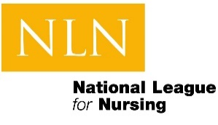
Process for Launching Your NLN On-Demand Course
The following information will need to be provided below in order to initiative your course for launch.
Please complete the following:
Title and Description of Course to be Identified in the On-Demand Catalog
What is the course offering?
What is the description of the course offering?

Compete the following information to assist NLN Communications to identify “How will the Course Work?” on the course catalog
Instruction: Asynchronous, Synchronous, Hybrid
Access: [time period course is open, is there more than one enrollment period]
CE designation: [total CE]
Effort: [length of time course takes]
Pace: [recommended pace if applicable]
Cost:
FAQs: [e.g. Who is the course intended for; what are the course expectations’ what additional resources are needed, etc.]

Please copy and paste this information directly into the Communications Request Form. You can obtain access to the communications request form here: NLN Communications Department Project Request
Once Communications receives this information, they will begin to coordinate building out the Course Catalog page for your new course and connect with Events and IT for connecting your course to the E-Commerce site as appropriate.

