PEDI Simulation- Plan B

Learning Objectives:
- Understand the pathophysiology, diagnosis, and treatment of pediatric DKA.
- Demonstrate clinical judgment in managing fluid and electrolyte imbalances.
- Practice appropriate insulin administration and monitoring.
- Enhance communication skills for patient/family education regarding diabetes management.

Scenario Overview:
Bella Swan, a 13-year-old with Type 1 Diabetes, arrives at the emergency department with symptoms of vomiting, deep breathing, and confusion. Her family reports that she has not been feeling well for the past 2 days and has had increased thirst and urination. Emily's blood glucose was over 600 mg/dL this morning at home, and her mother administered insulin as instructed, but Emily did not eat much today and has been vomiting intermittently.
- HR: 120 bpm
- BP: 100/60 mmHg
- RR: 28 breaths/min, Kussmaul respirations
- Blood glucose: 625 mg/dL
- Arterial pH: 7.22 (indicating acidosis)
- Serum bicarbonate: 10 mEq/L (low)
- Urine ketones: Positive

Supplies needed for this simulation:
- Manikin w/ IV
- Alaris pump with (3) channels
- Alaris Primary line x3
- Accucheck machine
- Oxygen nasal cannula
- Code cart nearby (not actively in use)
- Injecta-pad
- Insulin syringes x2
- Normal saline flushes x5
- Lactated Ringer 1L bag
- 3ml syringes x3
- Fill needle x3
- Zofran IV
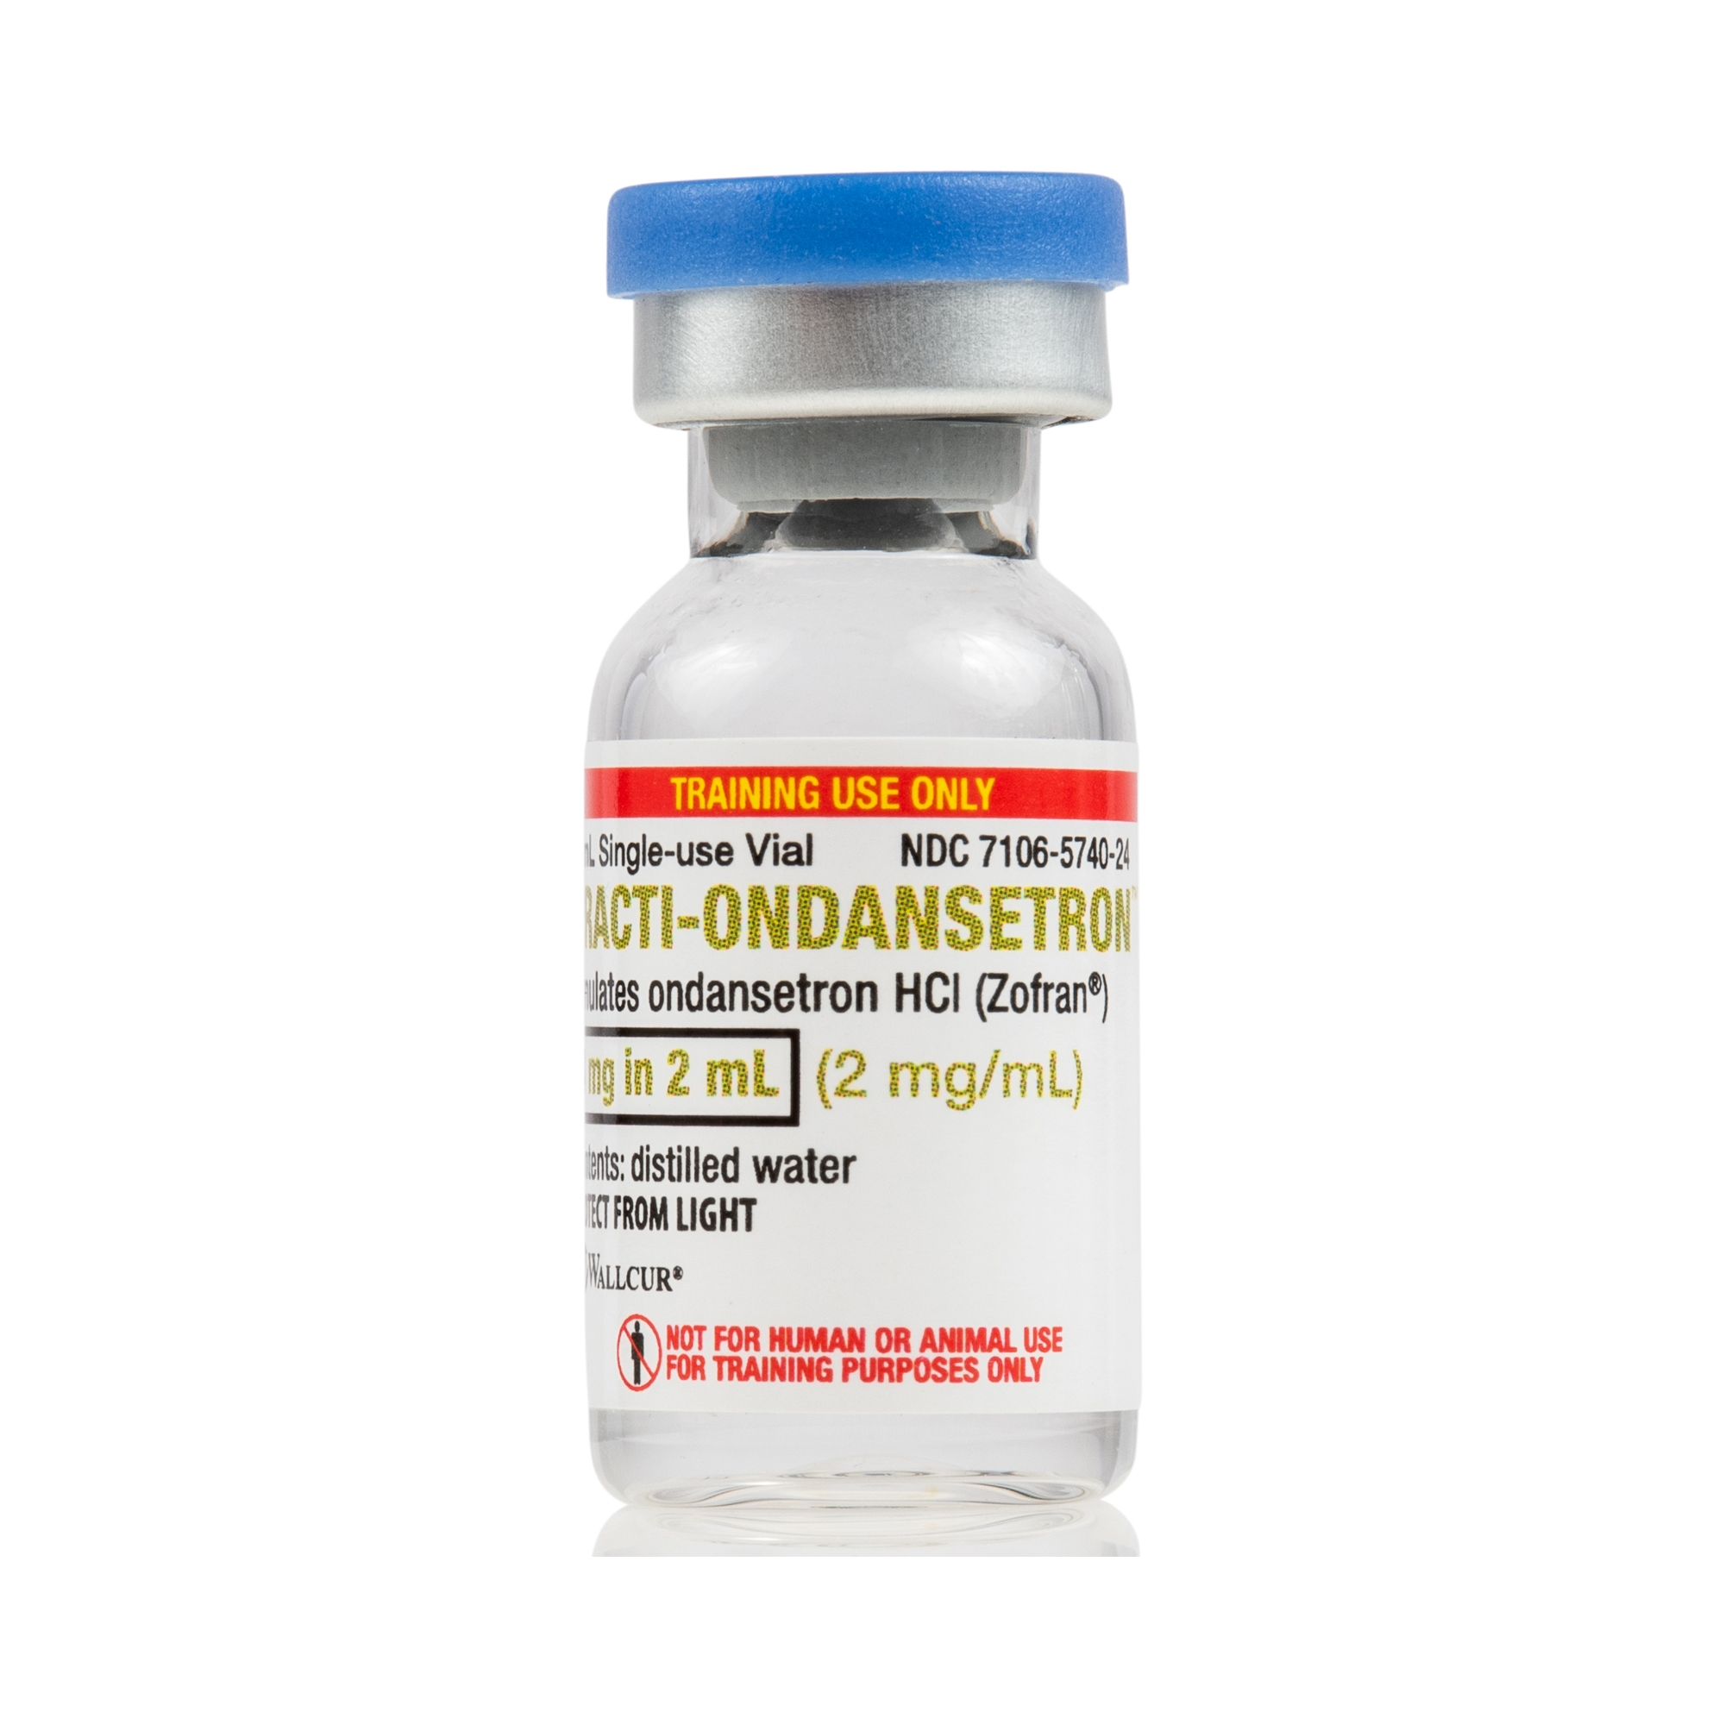
- D50% IV
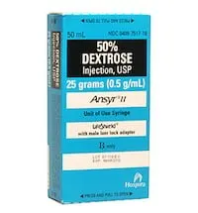
- Insulin IV
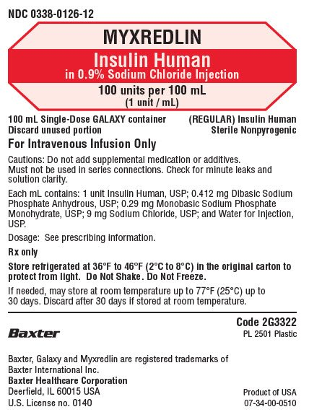
- Potassium chloride (KDur) 20 mEq tabs (10)
- Potassium chloride (KCl) 20 mEq IV
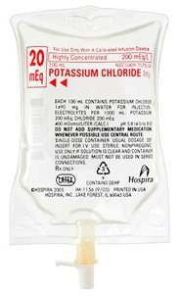

Scenario A- Group 1

Initial Assessment and Stabilization (Day Shift)
Patient Arrival: Bella Swan, 14 years old, presents vomiting, deep breathing, and confusion to the ED. Her blood glucose is elevated and has positive ketones in her urine.
Time | Settings | Expected Participant Actions | Facilitator Cues
1-5 min  PHASE 1 | Initial State:  HR: 120 bpm  BP: 100/60  RR: 30 (deep, labored) Kussmaul respirations  Temp: 99.1°F set in Progra-temp Simulator  SpO₂: 97% RA  Blood Glucose: 525 mg/dL  Urine Ketones: Positive | - Introduces self  - Performs hand hygiene prior to patient contact  - Identifies patient x2  - Analyze vital signs  - Neurologic assessment: Confused, slow to answer questions  - Respiratory assessment: Deep, labored, Kussmaul respirations | If students forget neuro assessment:  More confused and says: “I feel weird… my head hurts.”  Initiate 'PHASE 2' after the student has performed assessment.
5-10 min  PHASE 2 | Change in condition:  HR: 125 bpm  BP: 99/59  RR: 28 (deep, labored) Kussmaul respirations  SpO₂: 97% RA  Initial Lab Results (available after students request or draw labs)  pH: 7.22  HCO₃: 10 mEq/L  Potassium: 4.8 mEq/L  Sodium: 130 mEq/L  Glucose (lab): 344 mg/dL *Delay till end of phase | - Draw labs for blood gases, electrolytes, and glucose.  - Start Lactated Ringers @ 100 ml/hr  - Start IV insulin drip at 8 unit/hr  - Perform SBAR to MD for lab results | If students delay intervention to monitor vitals:  - HR increases to 132  - BP drops to 92/54  Once Student Calls MD  SBAR #1 orders will be received from Observer/Provider

“Rapid-Fire Report”- students begin their patient report to the next group. Students should report:
S – Situation
“Emily is a 14-year-old, newly diagnosis Type I DM, admitted for DKA with initial glucose of 525.”
B – Background
“She presented with vomiting, Kussmaul respirations, and confusion. Positive ketones.”
A – Assessment
“pH 7.22, low bicarbonate. IV fluids running. Insulin drip at 8 unit/hr. Glucose now 344.”
R – Recommendation
“Continue hourly glucose monitoring. Adjust insulin per protocol. Monitor electrolytes and neuro status closely.”

Scenario B- Group 2

Ongoing Monitoring and Adjustment (Night Shift)
Patient transfer to ICU: Bella Swan, 14 years old, continues to be monitored for DKA. She is following protocol to manage her blood glucose and any electrolyte imbalances.
Time | Settings | Expected Participant Actions | Facilitator Cues
1-5 min  PHASE 1 | Initial State:  HR: 118 bpm  BP: 102/64  RR: 24  SpO₂: 98% RA  Blood glucose: 315 mg/dL | - Introduces self  - Performs hand hygiene prior to patient contact  - Identifies patient x2  - Analyze vital signs  - Neurologic assessment: Alert but, drowsy  - Respiratory assessment: (less labored than Phase 1)  - Continue hourly glucose checks  - Adjust insulin drip at 5.7 unit/hr.  - Redraw labs for blood gases & electrolytes. | Patient is in bed and is quiet  If students fail to adjust insulin:  “This is Endocrinologist checking on Bella, is she still on the insulin drip? How many units? What was her last glucose?”  Initiate 'PHASE 2' after the student has performed assessment.
5-10 min  PHASE 2 | Change in condition:  HR: 118 bpm  BP: 102/64  RR: 24  SpO₂: 98% RA  Repeat Labs (available after students request or draw labs)  Blood glucose: 227 mg/dL  Potassium: 2.9 mEq/L (CRITICAL LOW)  pH improving: 7.29  HCO₃: 14 mEq/L | - Identify potassium 2.9 as critical  - Initiate IV Potassium Replacement per protocol  - Continue hourly glucose checks  - Adjust insulin drip at 3 unit/hr.  - Reassure patient/family and continue updating them on progress. | If students do NOT recognize critical potassium:  Lab calls “I have a critical potassium of 2.9 to report. Who am I speaking to?”

“Rapid-Fire Report”- students begin their patient report to the next group with real-time interruptions and unexpected updates: Parent calls to speak with the nurse for updates.
Student should report:
S – Situation
“Emily is a 14-year-old admitted to ICU for DKA; newly diagnosis Type I DM.”
B – Background
“Initial glucose 315. Insulin infusion at 5.7 unit/hr. and fluids started.”
A – Assessment
“Current glucose is 227 mg/dL. Critical potassium of 2.9. 60 mEq Potassium replacement initiated. Cardiac monitoring ongoing. No signs of cerebral edema.”
R – Recommendation
“Continue hourly glucose checks. Monitor ECG closely. Consider insulin rate reduction if glucose continues to drop.”

Scenario C- Group 3

Gradual Stabilization (Day Shift)
Patient at ICU: Bella Swan, 14 years old, continues to be monitored for DKA. She is following protocol to manage her blood glucose and any electrolyte imbalances.

Time | Settings | Expected Participant Actions | Facilitator Cues
1-5 min  PHASE 1 | Initial State:  HR: 90 bpm  BP: 112/70  RR: 18  SpO₂: 98% Room Air  Blood Glucose: 90 mg/dL (critical low) | - Introduces self  - Performs hand hygiene prior to patient contact  - Identifies patient x2  - Analyze vital signs  - Neurologic assessment: groggy  - Respiratory assessment  - Continue hourly glucose checks  - Stop the insulin drip  - Redraw labs for electrolytes. | Patient is in bed and is quiet  If students do not stop the insulin drip:  “I feel so groggy”  Initiate 'PHASE 2' after the student has performed assessment.
5-10 min  PHASE 2 | Continue initial state:  Repeat Labs (available after students request or draw labs)  Blood glucose: 125 mg/dL  Potassium: 4.2 mEq/L | - Reassesses glucose  - Educate the family about the signs and symptoms of hypoglycemia | If family education is lacking:  “Why did this happen? Will it happen again?”

“Rapid-Fire Report”- students begin their patient report to the next group with real-time interruptions and unexpected updates. Student should report:

S – Situation
“Emily is a 14-year-old with DKA. Her glucose has dropped to 90 mg/dL.”
B – Background
“Newly diagnosis Type I DM. Started treatment with IV fluids and insulin.”
A – Assessment
“Blood glucose now 125 mg/dL, potassium stable at 4.2 mEq/L, mental status improving. Insulin drip stopped.”
R – Recommendation
“Continue glucose monitoring. Reassess electrolytes and monitor for signs of hypoglycemia. Educate family on signs of low glucose.”

Scenario D- Group 4

Hypoglycemic Episode (Night Shift)
Patient at ICU: Bella Swan, 14 years old, continues to be monitored. She is following protocol to manage her blood glucose.
Time | Settings | Expected Participant Actions | Facilitator Cues
1-5 min  PHASE 1 | Initial State:  HR: 118 bpm  BP: 125/67 mmHg  RR: 10  SpO₂: 98% RA  Blood Glucose: 56 mg/dL (critical low) | - Introduces self  - Performs hand hygiene prior to patient contact  - Identifies patient x2  - Analyze vital signs  - Neurologic assessment: groggy with confusion  - Continue hourly glucose checks  - Recognize symptoms of hypoglycemia  - Redraw labs for electrolytes | If glucose is not checked:  “My head feels funny and I’m shaking.”  Initiate 'PHASE 2' after the student has performed assessment.
5-10 min  PHASE 2 | Continue initial state:  Repeat Labs (available after students request or draw labs)  Blood glucose: 120 mg/dL  Potassium: 4.4 mEq/L | - Administer Glucose (Oral or IV)  - Monitor mental status  - Continue hourly glucose checks | If glucose is not administered:  Non-responsive, drop RR 8, SpO₂ 94% RA  Initiate 'PHASE 3' after intervention.
10-15 min  PHASE 3 | Stabilize state:  HR: 105 bpm  BP: 110/65 mmHg  RR: 12  SpO₂: 98% RA | - Provides therapeutic communication to patient/parent
“Rapid-Fire Report”- students begin their patient report to the next group with real-time interruptions and unexpected updates: MD makes rounds and orders to start sliding scales and ACHS glucose checks. Student should report:

S – Situation
“Emily is a 14-year-old newly diagnosis Type I DM. Admitted for DKA. Her glucose dropped to 56 mg/dL.”
B – Background
“Her insulin infusion been off and we started ACHS glucose check per sliding scale.”
A – Assessment
“After administering IV/PO glucose, her glucose is improved to 120 mg/dL and potassium was stable at 4.4 mEq/L. Her mental status improved but she’s still groggy.”
R – Recommendation
“Continue to monitor glucose levels closely & subcutaneous insulin.”

Scenario E- Group 5

Discharge Planning (Day Shift)
Discharge from ICU: Bella Swan, 14 years old, continues to be monitored for DKA. She is following protocol to manage her blood glucose and any electrolyte imbalances.

Time | Settings | Expected Participant Actions | Facilitator Cues
1-5 min  PHASE 1 | Initial State:  HR: 90 bpm  BP: 105/70  RR: 20  SpO₂: 98% RA  Blood Glucose: 115 mg/dL (stable and safe) | - Introduces self  - Performs hand hygiene prior to patient contact  - Identifies patient x2  - Analyze vital signs  - Neurologic assessment: Fully alert, no confusion  - Check glucose | Patient is in bed and  alert  Initiate 'PHASE 2' after the student has performed assessment.
5-10 min  PHASE 2 | Continue initial state: | - Complete discharge patient education | If family education is lacking:  “How do I keep track of my blood sugar?”

“Rapid-Fire Report”- students begin their patient report to the whole group. Expected Report Content:

S – Situation
“Emily is a 14-year-old who was admitted for DKA. Her glucose is now stable at 115 mg/dL. We transitioned her insulin from IV to subcutaneous.”
B – Background
“She was initially treated for DKA with IV insulin and fluids. Potassium was stable at 4.0 mEq/L. Alert and oriented.”
A – Assessment
“Emily is stable, and we’ve ensured the family understands her insulin regimen, diet, and how to prevent DKA.”
R – Recommendation
“Schedule follow-up appointment with the endocrinologist.”

Diabetic Ketoacidosis (DKA) Protocol

Diagnostic Criteria for DKA
Diabetes: Glucose $≥$ 200 mg/dL OR prior history of diabetes
Ketosis: $β$-hydroxybutyrate $≥$3.0 mmol/L OR positive urine ketones
Acidosis: pH <7.0 AND/OR bicarbonate <18 mEq/L

General Nursing Orders
- Monitor blood glucose every 1 hour unless otherwise specified
- Lactated Ringers at 100 mL/hour IV infusion
- Start Regular Human Insulin 100 units in NS 100 mL IV infusion
- Draw labs every 6 hours:
Venous Blood Gas
Comprehensive Metabolic Panel
- Treat potassium per DKA replacement protocol

POTASSIUM REPLACEMENT
Potassium Level (mEq/L) |  | Potassium Chloride Dose |  | Monitoring
LESS than 3.0 |  | 60 mEq oral or IV |  | Repeat potassium level in 2 hours
3.0 - 3.5 |  | 40 mEq oral or IV |  | Repeat potassium level in 2 hours
3.6 - 4.0 |  | 20 mEq oral or IV |  | Repeat potassium level in 2 hours
GREATER than 4.1 |  | No replacement |  | Repeat potassium level in 2 hours
INSULIN DRIP ORDER
Glucose (mg / dL)
50 or less | 1. Turn infusion off. Give D50% 50mL IV PUSH. Notify physician.  2. Recheck blood glucose every 30 minutes until glucose is greater than 70 mg/dL.  3. When blood glucose is GREATER THAN 140 mg/dL, restart infusion at the appropriate rate.
51 – 69 | 1. Turn infusion off. Give D50% 25mL IV PUSH or ½ cup of juice.  2. Recheck blood glucose every 30 minutes until glucose is greater than 70 mg/dL.  3. When blood glucose is GREATER THAN 140 mg/dL, restart infusion at the appropriate rate.
70 - 99 | 1. Turn infusion off.  2. Recheck blood glucose every 30 minutes until glucose is > 70 mg/dL.  3. When blood glucose is GREATER THAN140 mg/dL, infusion at the appropriate rate.
Glucose (mg / dL) | Low Dose Algorithm (units/hour)
100-119 | 0.2
120-139 | 0.5
140-159 | 1
160-179 | 1.5
180-199 | 2
200-219 | 2.5
220-239 | 3
240-259 | 4
260-279 | 4.5
280-299 | 5
300-319 | 5.7
320-339 | 6.5
340-359 | 7
360 or more | 8

Patient Information
 | Name: Bella Swan | Gender: Female
 | Age: 13 | DOB: 12/15/XX
 | Weight: 50 kg
 | Allergies: NKDA | Code Status: Full Code
Prior Medical History:

Type 1 Diabetes Mellitus (diagnosed at age 8), Mild intermittent asthma
Recent Medical History:

Admitted yesterday for from school by her mother with vomiting and labored breathing to the ED. Her blood glucose is elevated

Time: 0900
Report:

Bella Swan is an adolescent female. Alert but confused. On room air; no complaint of shortness of breath. Voids and reported BM yesterday. She has a peripheral IV to her left forearm. Last set of vital signs:

HR: 120 bpm
BP: 100/60
RR: 30
Temp: 99.1°F
SpO₂: 97% RA

Patient Name: Bella Swan |  |  |  | Chief Complaint: Type 1 Diabetes Mellitus (DM)
DOB: 12/15/XX  Age: 13-year-old  Height: 150 cm |  |  | MR#: PCS15900  Gender: Female  Weight: 50 kg | Chief Complaint: Type 1 Diabetes Mellitus (DM)
ð Allergies: No Known Drug Allergies (NKDA)

Date | Time | PHYSICIAN ORDER AND SIGNATURE
02/14/XX |  | Titrate to keep SPO2 above 92%
 |  | Telemetry monitoring
 |  | Fall precautions
 |  | Hourly blood glucose checks
 |  | Arterial Blood Gas STAT
 |  | Comprehensive Metabolic Panel STAT
 |  | Lactated Ringers 500 mL IV bolus over an hour STAT
 |  | Initiate Diabetic Ketoacidosis (DKA) Protocol
 |  | Zofran (ondansetron) 2 mg IV every 4 hours PRN- nausea/vomiting
 |  | Provide client/caregiver education
 |  | Transfer to Pediatric Intensive Care Unit (PICU)
PHYSICIAN/PROVIDER SIGNATURE
PHYSICIAN ORDERS

Pre-Work Assignment: Pediatric Diabetic Ketoacidosis (DKA)
Please review the following materials before the simulation:
- Overview of Diabetic Ketoacidosis & Type I DM

